Blog Post – Comment : -

* Create Database : post_comment.

Run following command :

-composer install.

-php artisan migrate.

-php artisan db:seed --class=RolesTableSeeder

-php artisan db:seed --class=AdminSeeder

* Register Page with validation (user):

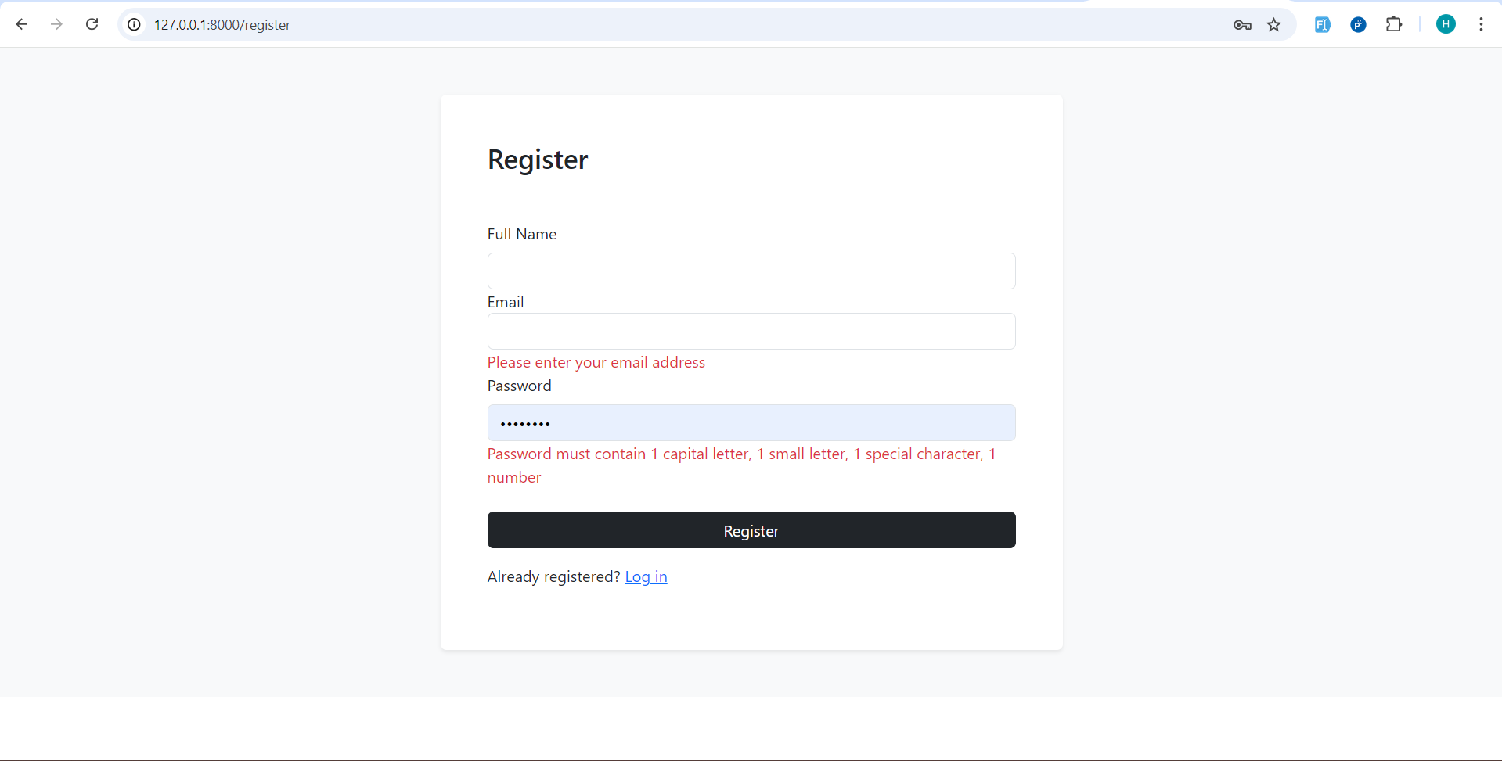

* Login Page (user & admin):

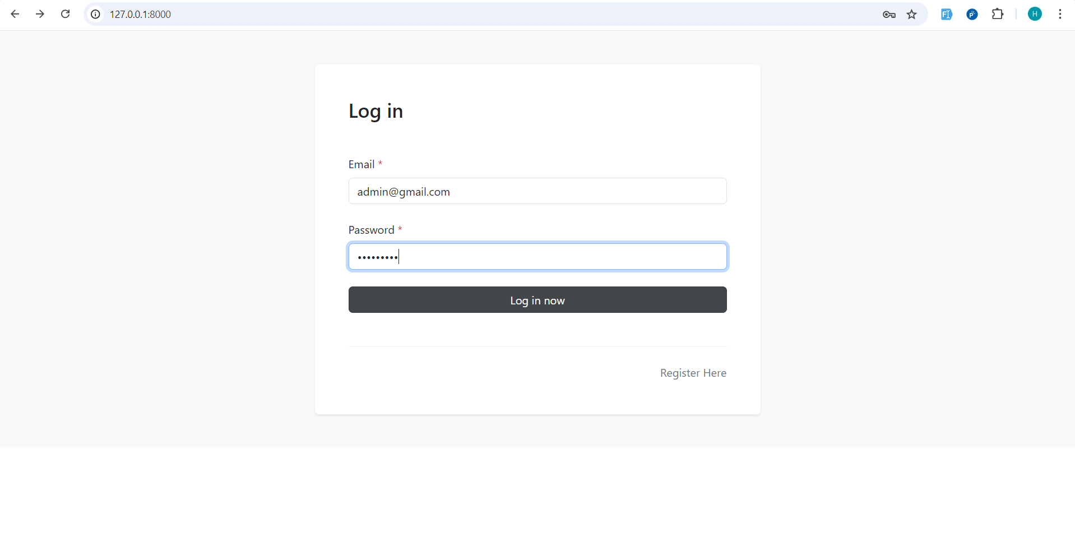

* Admin Can Create , Edit, Delete Users :

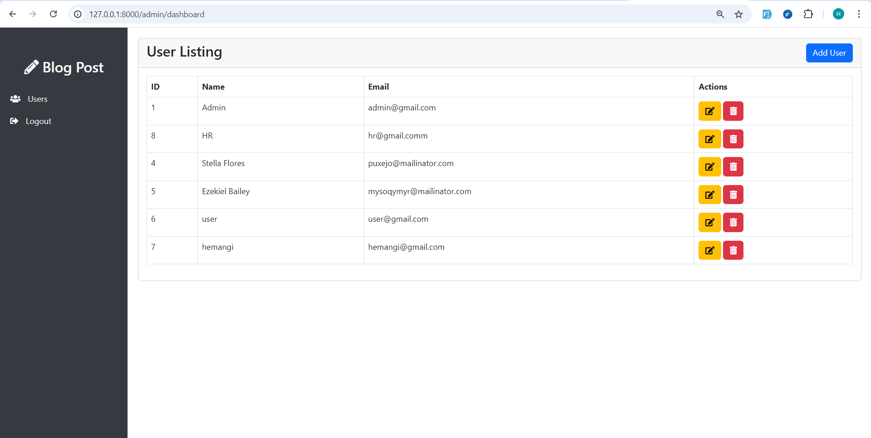

* Create User with validation :

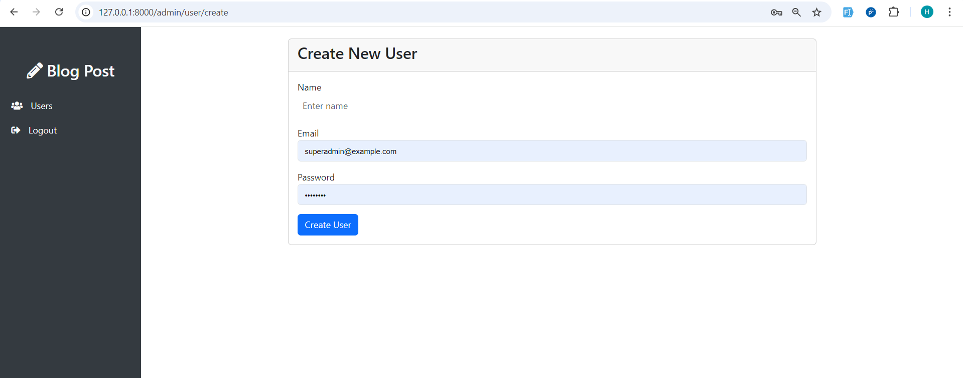

* Edit User By Admin :

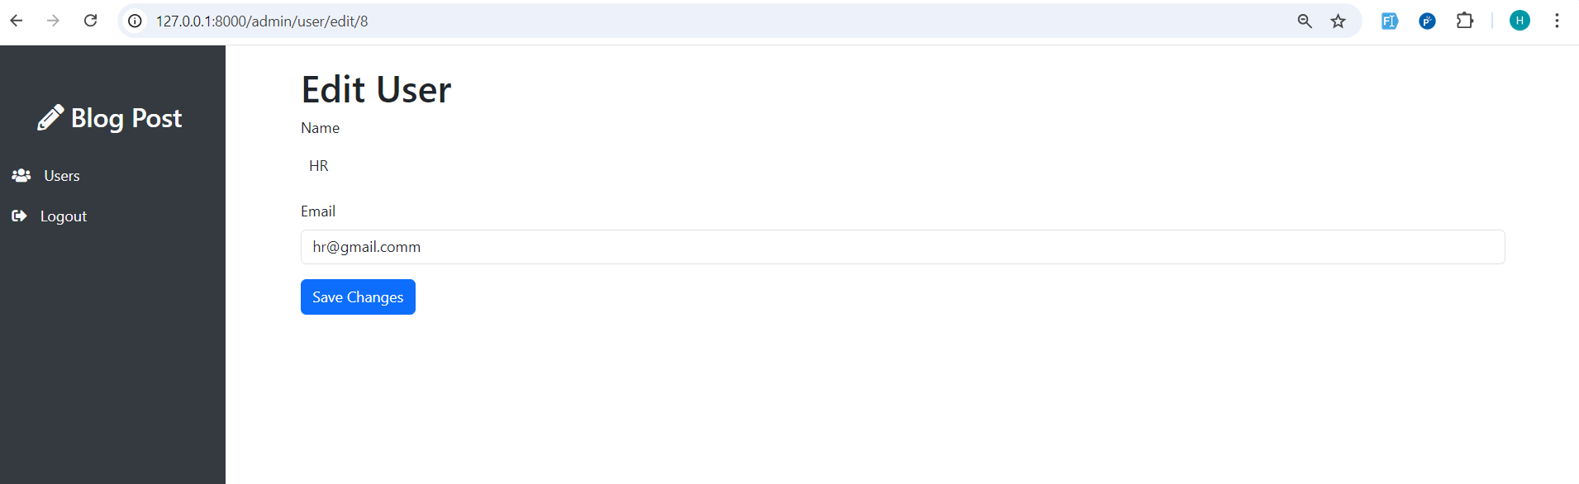

* User Delete By Admin With Confirmation :

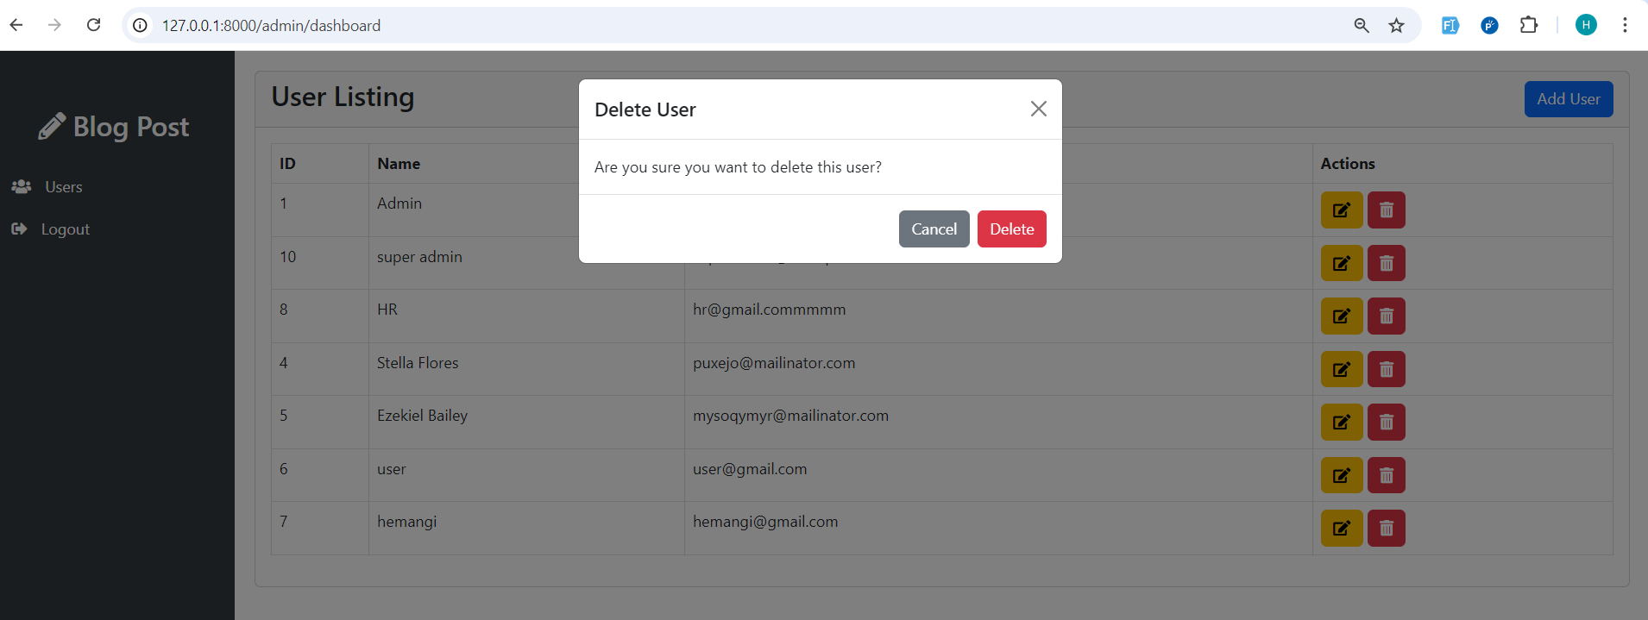

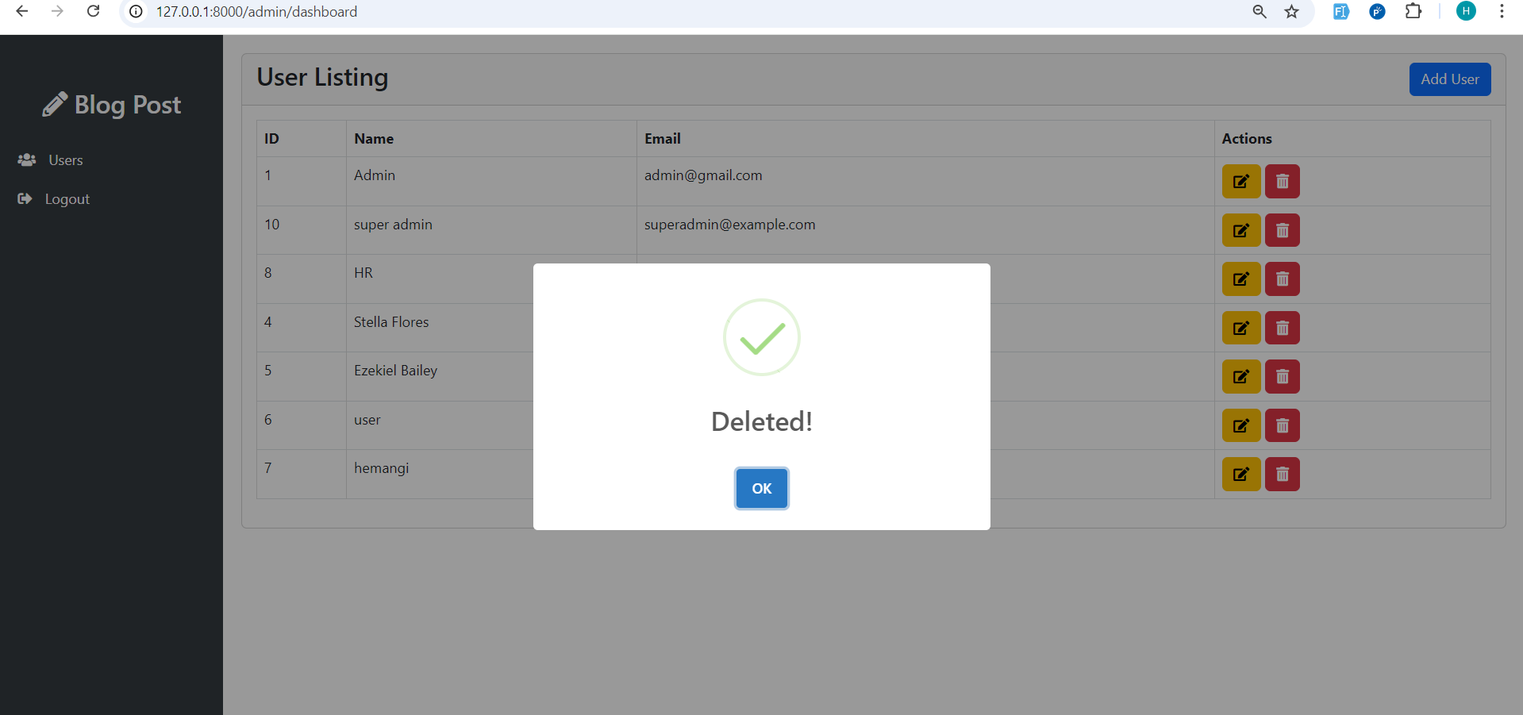

* User Login :

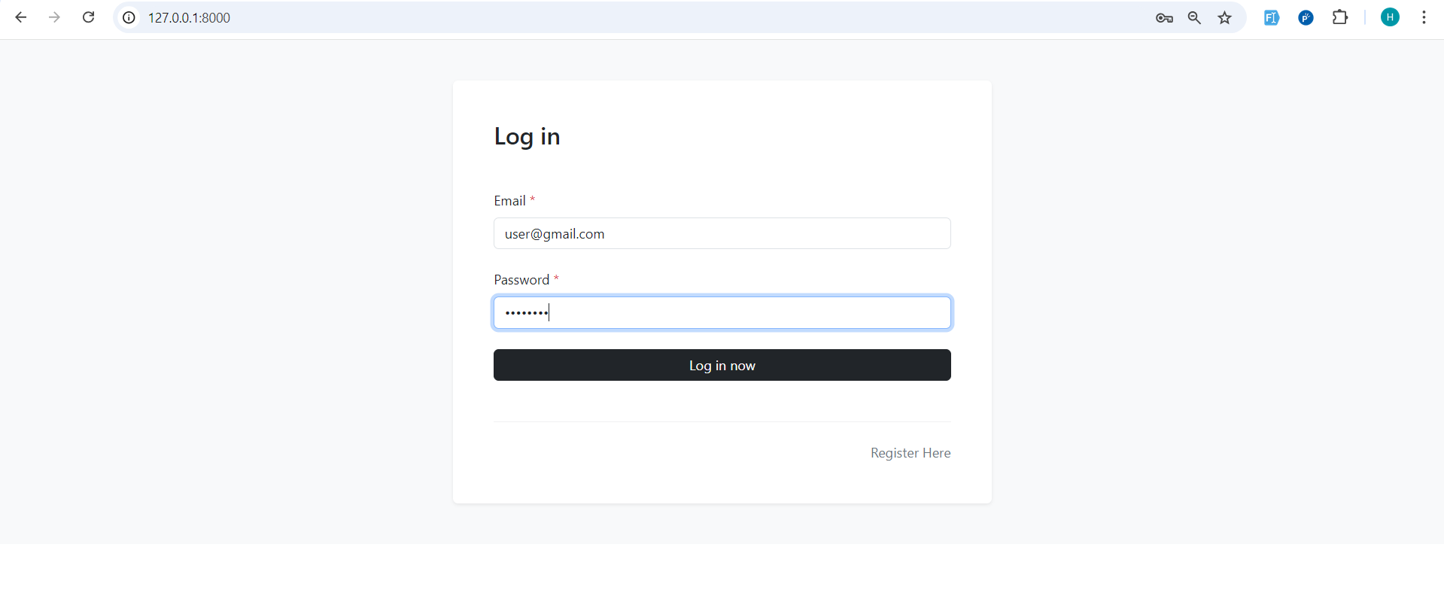

* User Can Create , Edit , Delete Their Own Posts:

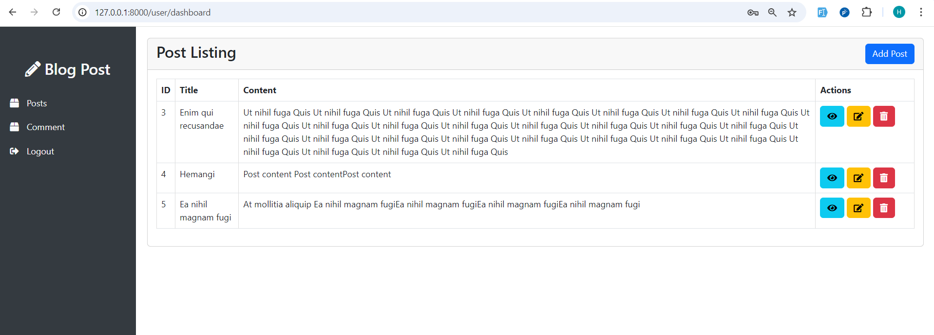

* Add Post (user) :

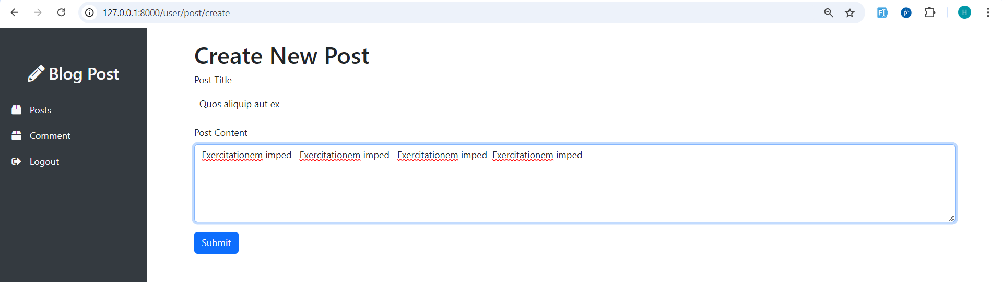

* Edit Post(user):

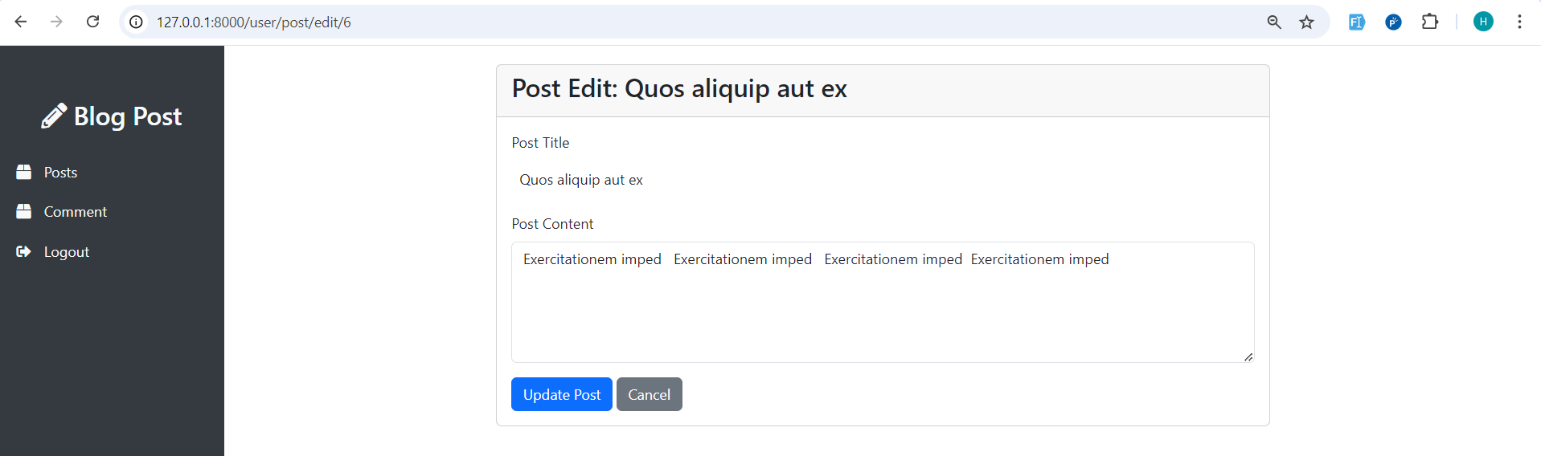

* Delete Post with confirmation :

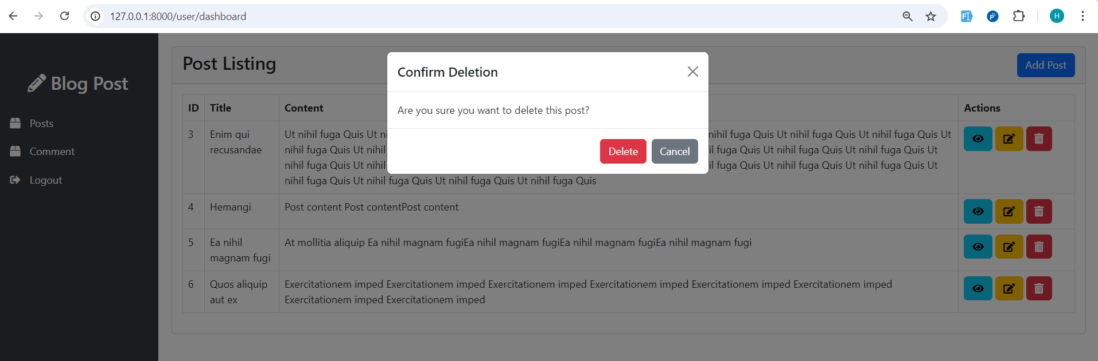

* Add Comment of post :

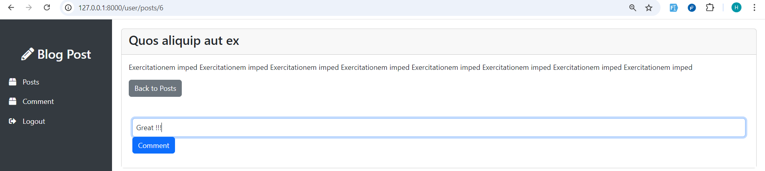

* Add Multiple comments from here and also update and delete:

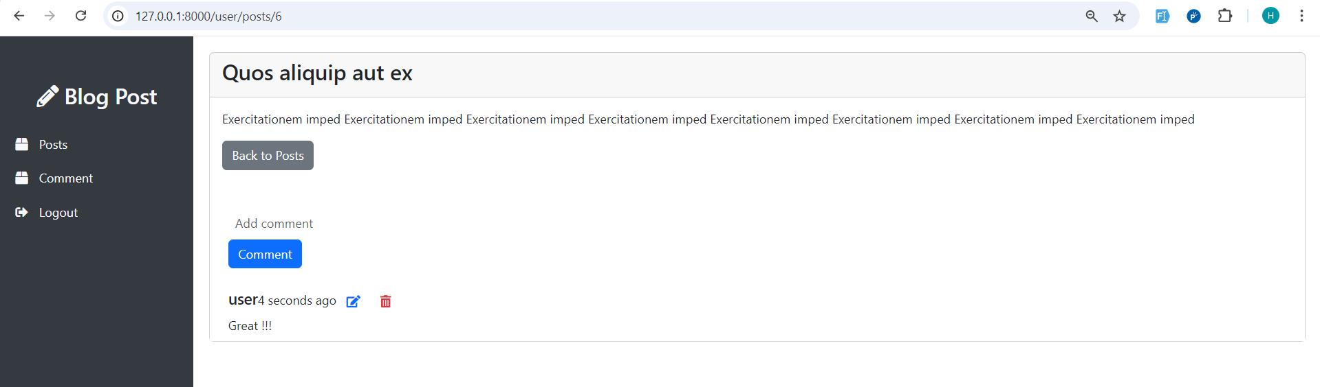

* Edit Comment :

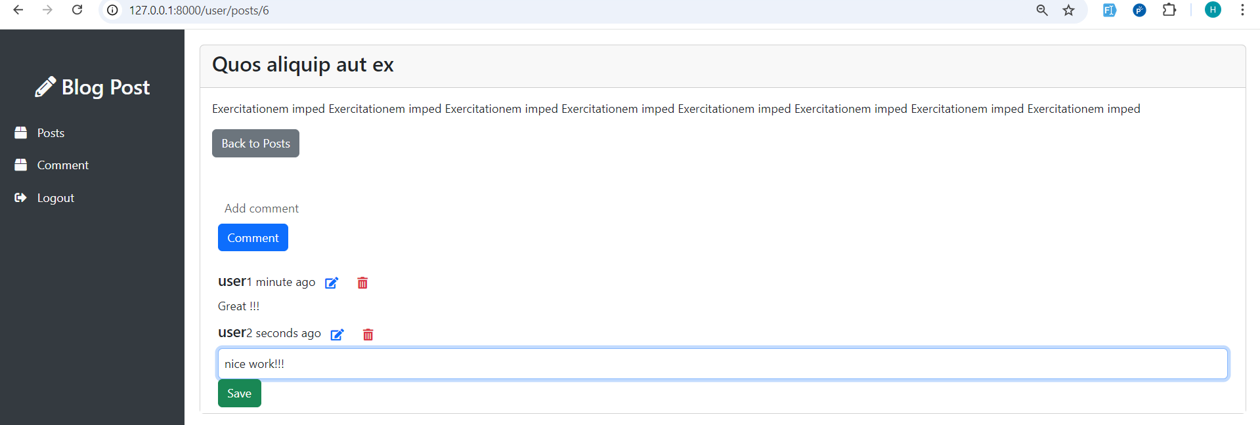

* Delete Comment :

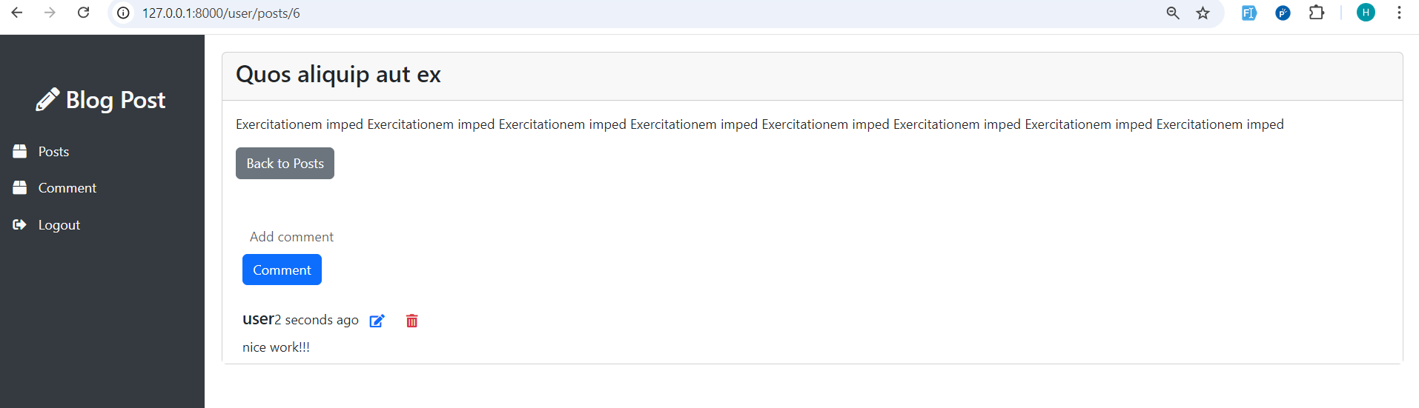

* Comments Listing :

